PROJECT TITLE : Industry-specific intelligent fire management system

TEAM LEADER- BRAHADEESHRA R TEAM MEMBER 1- HARIKRISHNA S TEAM MEMBER 2- HARIHARAN S TEAM MEMBER 3-HARISH P

Environmental Damage

Sudden accidents at home or other workplaces

Huge loss to the authority

Public Disturbance

Install Fire Extinguishers

People get updated by using this technology

Use flammable products carefully

Alerts the society to be updated and safe

# Make use of Watson IOT platform

Connecting IOT devices with Watson IOT platform

Creation of web application

Sending Notifications to the concerned authorities

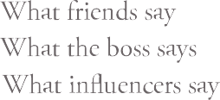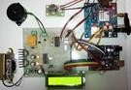

Managing different sensors at a time

Maintenance o not allowing any interruption in services

Fire disasters are reduced

# Technology is upgraded